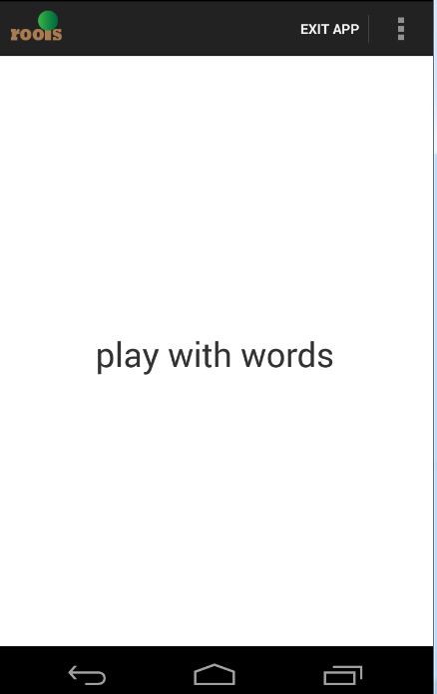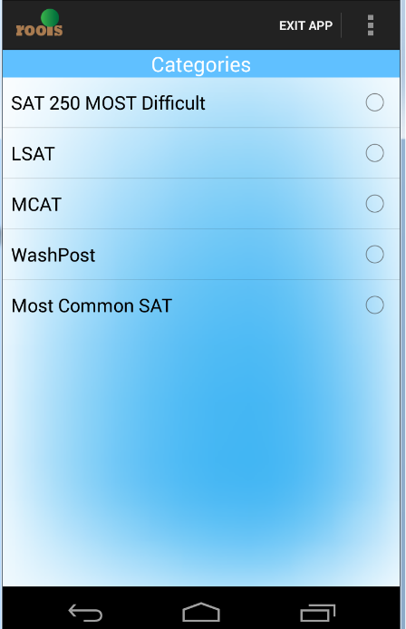

MainAcitivity.class



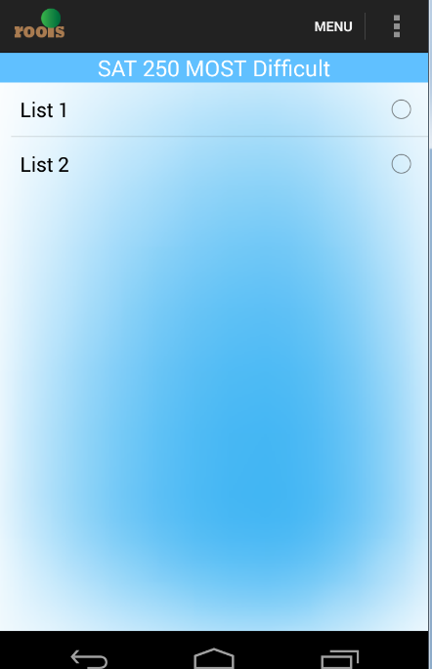

Listselectactivity.class



public String underlineclear(String key)

this method is used to replace the” _” to “ ” from course name

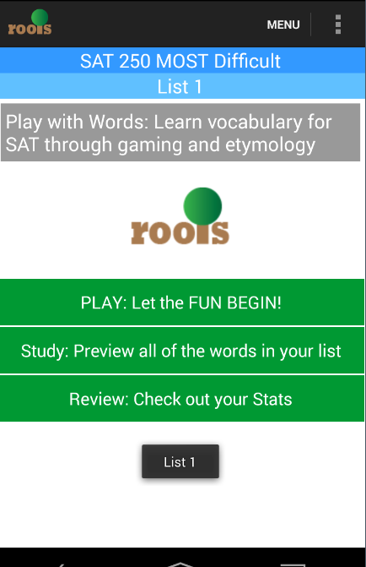

List.class

List.class



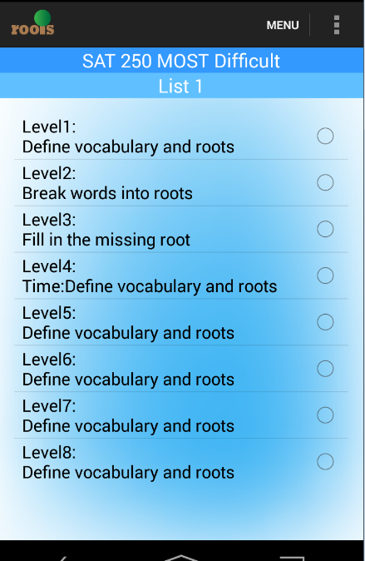

Play.class



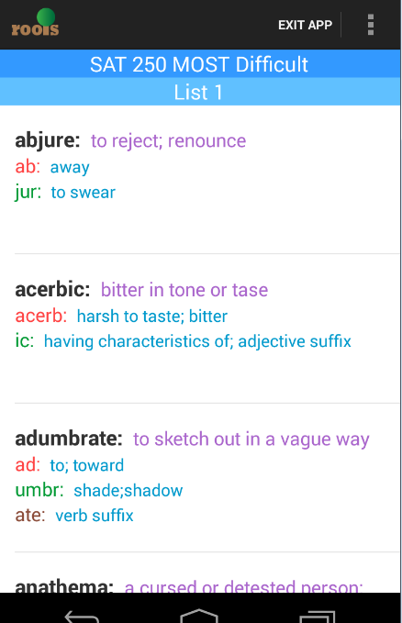

Studywordcolor.class



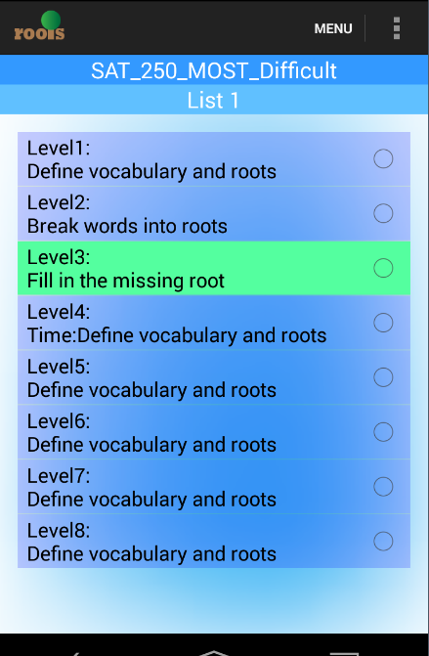

Reviewlevel.class



For Level 1 to 8.

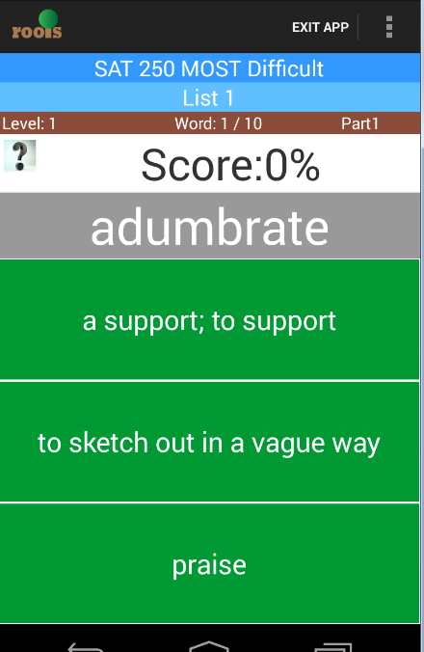

Definition.class

private void ran() : this method is used to assgin the options.

private String[] getroots(): collect all available options.



Definition.class



Defintin l2.class



Defintionl4.class



Definitionl8.class

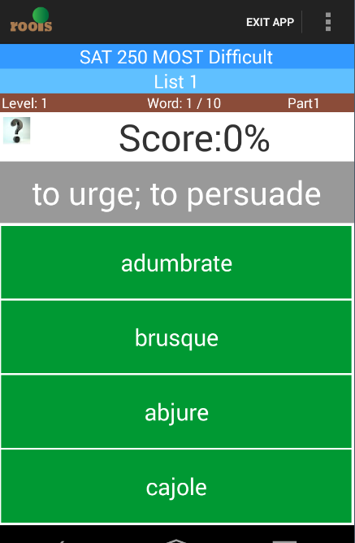

Words.class



Word.class like defition.class

Wordl2.class like defintionl2.class

L4 like l4

L8 like l8

So don’t repeat draw in word.

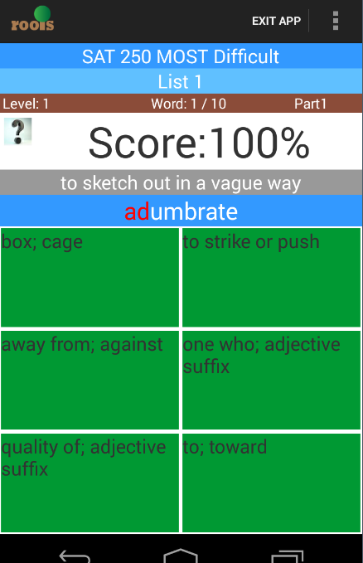

Root.class

private SpannableStringBuilder getchangeword()

this medthod is change relevent part of word’s root turn to red.



Root.class



Rootl2.class



Rootl4.class



Rootl6.class

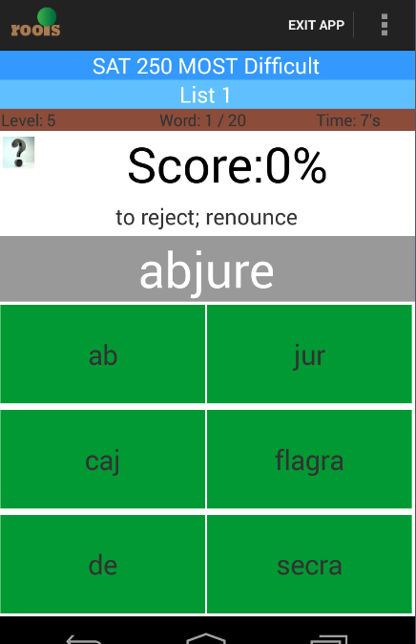

Idroots.class

private SpannableStringBuilder getchangeword(String key)

turn to red and bigger for relevent root parts.



Idrootl2.class



Idrootsl4.class



Idrootl5.class

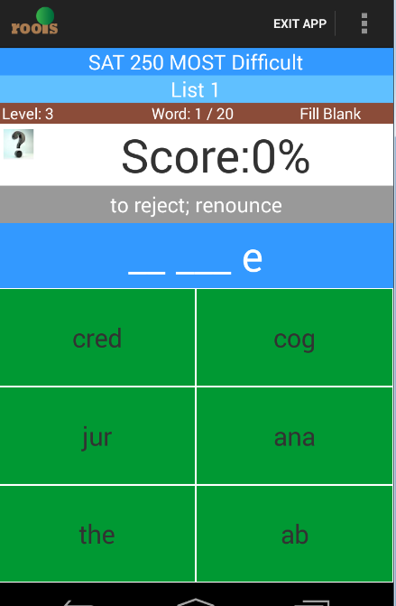

Missroot.class

private String getresultword(int key) 

private String getchangeword(int key) 

private String getchangeroot(String key) 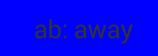



Missroot.class



Missrootl7.class

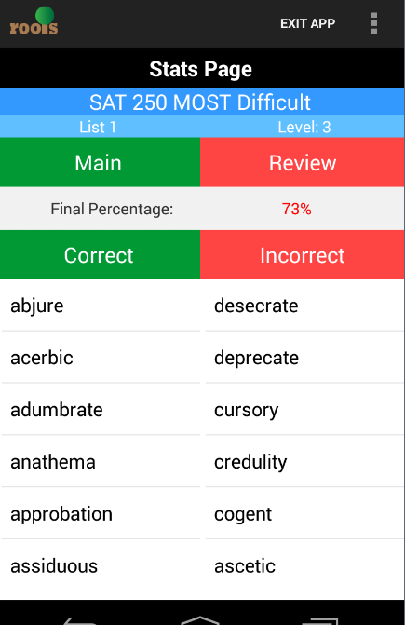

Score.class



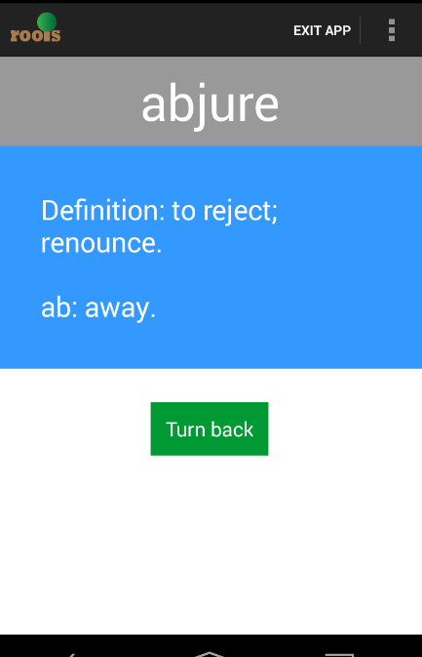

Scoreword.class

Introduce mypublicvalue.class all control values are relevent to this java. This java like the app cache.

public void setdefault() : all level helpbutton shaping functin reset, buttonsound open, and musicsound open. And green toast open

public void deletereviewrecord() : delete all wrongword recode in database

public void setsplashscreen() : set splashscreen has display.

public boolean getsplashscreen() : refer the splashscreen condition. True of false.

public void setmusic(int key, int value) :

key=0, set buttonsound, value =1 is open, value=0 is close

key=1, set musicsound, value =1 is open, value=0 is close

public int getmusic(int key) :

key=0.get buttonsound

key=1. Get musicsound.

public void setlistnum(int key) :

the amount of list =key.

public int getlistnum()

public void sethelpcontrol(int key, int p) : this medthod to set or store shaping contrl value for different activity

key=0, misroot

key=1, definition

key=2, idroot

key=3, root

key=4, greenhelp it is about greentoast

public int gethelpcontrol(int key)

public void greentoast() : display greentoast instruction.

public void Vibrate(): mobile vibrate

public String[][] getrootword()

return crootword

public void setrootword(String[][] word) it is about level5.

rootword=word

the two method is about rootword quicksort for using clean repeat rootword in wrongrootword.

public double getdefwordscore(int key)

public void setdefwordscore(int key, double number)

key=0,dewordclicknum=number

key=1, dewordrightnum=number.

public double getidrootscore(int key)

public void setidrootscore(int key, double number)

public double getrootscore(int key)

public void setrootscore(int key, double number)

public double getscore(int key)

public void setscore(int key, double number)

these method like setdefwordscore.

public void setranwords(String[][] key)

it is used to store 10 ranwods in level1 and level2.

public int getreviewwrongcontrol() public void setreviewwrongcontrol(int key): about wcon (review control value)

public int getrepeatcontrol()public void setrepreatcontrol(int key) : about con.(part control value in level1 and level2)

public String get(int seq)

seq=0. Return tablename or course name

seq=1 , return listname like “list1”

seq=2, return list number like 1

seq=3, return level number

seq=4, return word number.

Seq=5,return rootstep. For example , the first root in word[] is 2

Seq=6,return repeat number . it is about defrepeat() in every activity.

Seq=7, no use

Seq=8, return lv1. It is about level1 and level2 get 10 ranwords in first play.

public void setwords(String[][] words): get 20 words from databse and store in here.

public void addwrongword(String[] word). Store wrongword in regular condition

public void addwrongwords1(String[] word). Store wrongword in review condition.

In this activity, quicksort method like quicksort, quicksort1,quicksort2. It is use to clean repeat words in wrongwords.

public void empty1() : this method reset some control values. It should be used in regular condition end.

public void empty(): this method the whole control values, it should be use in review condition end.

public void playmusic(int key). This method is about soundpool function. It achieve button sound and wrongsound ,final sound

in this method, very sound resource, shoule be very tiny.

Key=1 button right

Key=0 button wrong

Key=2 5seond alarm

Key=3, failure sound

Key=4. Tick sound.

public void startsplashmusic(): this method is use to play backgound music. Like startsplashmusic.

public void pausesplashmusic(): pause backgound music

public void stopsplashmusic() : stop backgound music.

public String underlineclear(String key): this method is used to replace “_”to “ ”

managedb.java all functions about database are stored in here

public void CopyDatabase() : this function copy databse file from assets to mobile

public List<String> listtablename(String[] selectionArgs),

return all course name

public void deletereviewrecord()

delete all wrongwords in databse

public void deletewrongworddb()

delete wrongwords about relevent course level list

public void insertscore(int score, int scoredefword, int scoreroot,

int scoreidroot, int scoremisroot)

insert every score to databse.

public int[] getscore()

public void setdefault()

helpbutton shapeing function reset, music sound ,buttonsound reset, greenhelp toast rest.

public void updateacount(int key, int value)

accodring key, update relevent attribution. It is about helpbutton and musicsound and so on.

public int[] getacount()

it is about above attribution.

public void insertdb(String[][] words, String correct)

insert wrongword to databse.

public void coursereivewcreate(String tablename)

create course wrongwords table in databse.

public boolean levelexist(String level)

in reviewlevel.class, this function return weather level has been played.

public int numlist(String tablename)

return how many list in the course.

public void cleantdata()

clean words like “”;

public String[][] getwrongwords(String key)

take wrongwords.

public String[][] getwords()

take 20 words.

Notice :

1. Mangage database , every coures must have at least 20 words and a multiple of 20
2. Course name don’t have “ ” and “wrong”;
3. In database, the same root should have same definition.